Proposal for troop Construction Camp

Event Construction Camp
Who 2nd Baulkham Hills & possible invite a troop, must have scout craft
When term 1 2013
Where possibly Bundilla (close to home)
Purpose Activity camp for building several larger pioneering structures.
Catering patrol catering & cooking, leaders camp separate and cook for them selves
Pre-Work prepare sketch and explanation of several construction items

Structures Free Standing Flagpole
Kitchen table and wash stand
Tower
Bridge

Program
Friday night Move in
Saturday
Breakfast
1. teach and test red camp-craft knots and lashings for any who need it
2. start building construction, flag pole, table and kitchen etc
Lunch
3. Teach & test blue camp-craft knots and lashings
4. Continue construction tower, bridge.

Dinner
5. Evening meal blue camp-craft cooking for guests (leaders)
Red cooking for other scouts
6. Camp Fire

Sunday
Breakfast
7. Scouts own
8. dismantle structures & pack up
Lunch
depart

Possible Award scheme sign off
2 nights under canvas
Red Camp-craft 1 knots & lashings
Blue Camp-craft 1 knots & lashings
Red or Blue Construction badge
red and blue camp-craft cooking
fire & fuel, fire safety?
blue citizenship 1 ethics b scouts own (for 2 or 3 scouts)
Patrol activity badge for arranging camp equipment and catering

Pole Supplies
All of our big poles, extra poles available at Bundilla
All small tent poles and staves
All ropes
Builders Planks from Paul? (Bridge deck)

Free Standing Flagpole
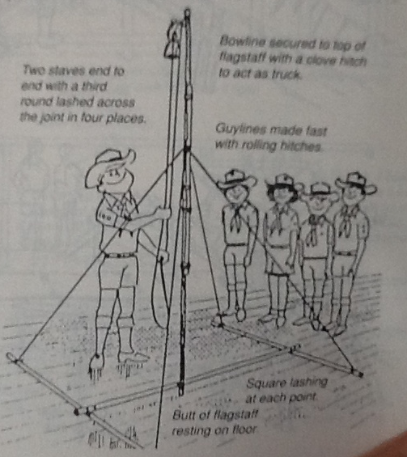
Equipment
7 medium poles
9 lashing ropes
1 flag
1 flag rope

Kitchen table / wash Stand /Kitchen equipment
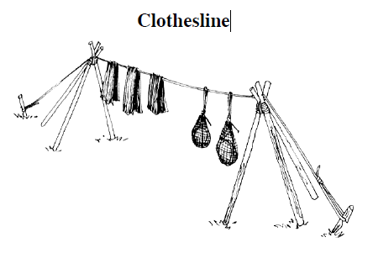
6 poles 2m
2 lashing ropes
1 long rope
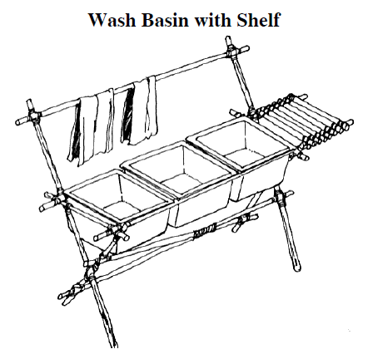

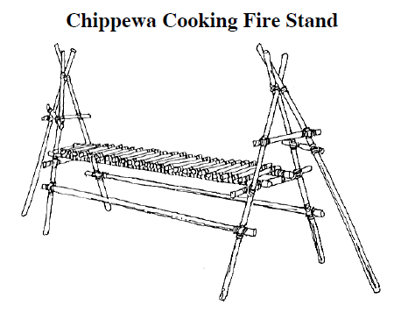

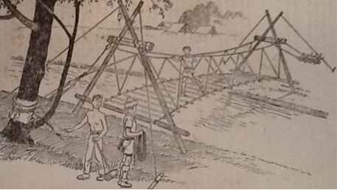
Rope Bridge with anchors built across Creek

Equipment
6 medium poles
4 long Ropes
6 lashing ropes
Decking
rope to tie down deck
2 anchors
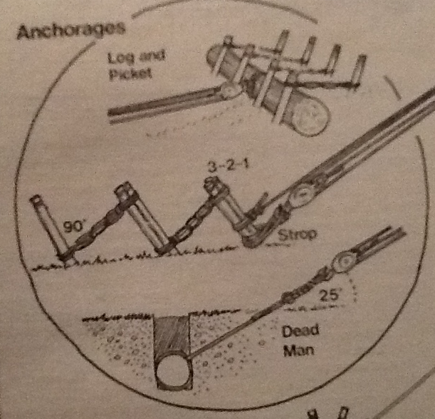

Tower
Equipment
6 long poles
9 short poles
poles for deck
20 lashing ropes
caving ladder
